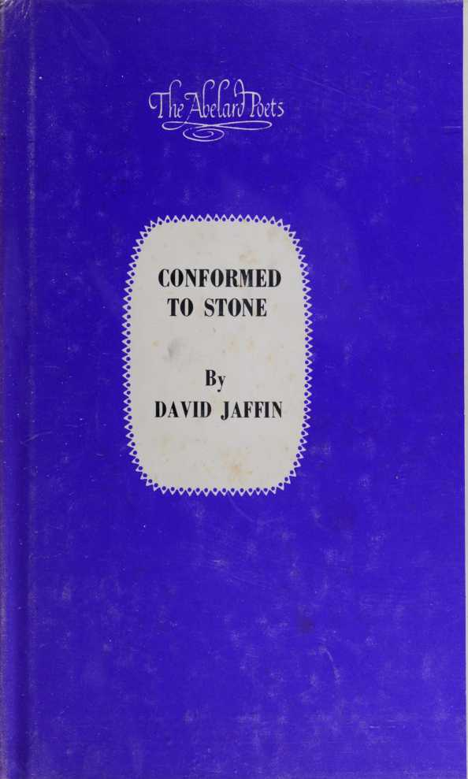

$2.50

CONFORMED TO STONE

by David Jaffin

This newest addition to “The Abelard Poets” introduces a young poet who sees more with the mind than with the eye. His poems are delicate and wistful, and concise in form and meaning, as he believes that “poetry is after all the art of absolute compression.” Mr. Jaffin uses a sparse abstract diction somewhat similar, because of their confessional tone, to certain Elizabethan sonneteers. This diction has, however, passed through the emotional mill of surrealism and found its form in the short line.

The poet creates an inner world of symbol and sense based upon recurring imagery, patterns of idea, and reinforced by the intensity of rhythm; a world reflective and lyrical, mystical and sensual, aesthetic and intellectual, social and satirical; a world of person and place, of touch and response, of God and the possibility of belief, of idea and the limitations to idea, of man and dehumanized man, of “passion conformed to stone.”

“I should hope that once one has truly entered ‘my world,’ the gate is forever closed behind him.”

CONFORMED TO STONE

DAVID JAFFIN



ij'arruet’

&

ABELARD-SCHUMAN

LONDON NEW YORK TORONTO

© Copyright 1968 by David Jaffin

Library of Congress Catalogue Card Number: 68-18971

Standard Book No. 200.71548.8

Printed in the United States of America

LONDON

Abelard-Schuman

Limited

8 King St. WC2

NEW YORK

Abelard-Schuman Limited 6 West 57 St.

TORONTO

Abelard-Schuman Canada Limited 1680 Midland Ave.

CONTENTS

The Winding Down 7

Raining 7

The Last Snow 8

Indecision 9

The Deer 10

For Grief 10

Woman in Mourning 11

Merry-Go-Round 12

To the Taste of Wine 13

In Defense of Free Will 14

From Summer’s End 14

Conformed to Stone 15

The Inexplicit 16

Study (woman around 50) 16

Sufficiently Human 17

The Idiot 17

Woodcarver 18

“Et in Arcadia Ego” II 18

Creatures of Stone 19

Self Portrait (at age 30) 20

The Quiet Within 21

The Fear of Winter 21

World that Wasn’t There 22

Anna’s Dream 23

Bruckner 24

Am I? 26

Abbreviations 26

Poem of Redemption 27

A Poem of Definition 28

Autumn Afternoon 28

The Last One 29

Professor K 30

Rachel 31

For mij wife, Rosemarie

The silence Of others had Blinded my

view (and the lamp), For I stood

At the top Of the stairs Awaiting the

Winding down (the steps): Material silence (and the manner of the fact).

RAINING

It was raining (i wanted to tell you i am not enough); Do you hear The rain, do You know what I want to tell you?

7

The snow had Come, there Was a sadness

In the night (though i could not

explain it to myself) Wanted to take

Your hand a- gain (and a- gain), hear the

Colors of Your dress— This loneliness

Of thought (as stars arranged in

the winter night), when I came to

You as a child (and wanted to be touched

and talked to) And told something that

Would waken your eyes-.

INDECISION

The afternoon Stood still,

A bird poised

Its song in The clear Light—what

Was it I Wanted to Say (relative

to song, or attributes of light)?

The afternoon Conscious of Neglect (and

I paused to reflect), a Bird balanced

with string.

We saw it First after The rains, it

Stood beside The advancing Columns of

Night, unafraid; What it knew Was only real

In the moment That it knew, The flight to

The world within.

FOR GRIEF

Wanted for Grief, the leaf Falls, as if

Hands pursued it there (through the

silent air)— That’s death: Alarms of light,

The final Calm of flight, Take me in

Your hands, Thus.

You should Forget (as i have done),

WOMAN IN MOURNING

Let light and Pleasure be, Become, appear, appropriate . . .

Winds could

Chill, your Hands would Take the blame—

Be not again A face and mar- belled hands.

MERRY-GO-ROUND

for S.E.

(and round a- bout the world would be, pleasurably turned); A mind of my Own (but cared

for less), as Candles blown But bright (and

round about the world would be); conversed

With stars

(though paper be their intent)—we Slowed, the Going smoothed

(as silk to be touched),

My mind was

A mind of silence (and round about

the world would be, pleasurably turned).

Thus as I Break this Bread (with coarse hands) And touch my Lips to the

Taste of wine (that sunlight shimmers in my veins),

The silence Between us is Broken too— My hands (as birds released in flight),

My lips form Your presence;

But lightly You come (rehearsed in whisper), your Dress woven of The wind, Jewelled with Seven stars, Your feet as

The falling of Leaves; but So lightly you Come that my Lips close your presence.

IN DEFENSE OF FREE WILL

Spring had Chosen its own Fancy (a floral

setting), whims Of light (and pipes of Pan),

Selected at Intervals (3rds and 4ths), and

She matched To her dress A fineness of

Scent and The fashions Of wind.

FROM SUMMER^ END for my father (the farm in Vermont)

The oars would Sing this sun Away into the

Wood at summer’s end,

The quiet regained, we Would glide As wind through

The grass;

Your hands Dipped again

At the current’s edge: This water

Was glass broken, the pond A child who

began to sing.

CONFORMED TO STONE

A poem is The clarity Of winter,

Light reflecting light,

Passion conformed to Stone; a poem Is the mirrored facade,

This gleam of Words reflected—

You wore a Velvet dress,

And, while I

Much admired It, preferred Your nakedness.

The permanent decline Of fact (and

i grasped at your hand) Through the

Fictions of Night (where stars subdued

and calmed)

To this bed Of stone and

Laughter,

Night ceased to define.

STUDY

(woman around 50)

Your face a

Web of sadness (the lines were broken through);

Deceptive words (the partial pain) patched

The image true.

SUFFICIENTLY HUMAN

A painted Smile (the rendered pose),

Sufficiently

Human to touch  
And expose

Where the lips Creased and Eyes opened

Full to the Artificial Light.

THE IDIOT

I looked for Light when The others were Away, found the Stone that was Almost me, pressed It hard, until I could smile.

WOODCARVER

(in memory of Barney Jafjin)

I carved with The tools of Winter, the Sharp branches,

The rook’s claw;

Remember when I Was old (burdened with shadowy shapes of the city), this Sharp sun go Down.

‘ ET IN ARCADIA EGO” II (Poussin/Panofsky)

Inscriptions Fade (distinguishing features):

Wounds of the Blade extracted From time (protracted), as the Chance of recognition.

Creatures of Stone confirmed as flesh

CREATURES OF STONE

Blood and bone, Insufficiencies Of time in the

Shadows of the Fact (diminishing probabilities of Thought); creatures of stone

(features of man), constructions of the

Idea (transitions fail).

SELF PORTRAIT

(at age 30)

I saw in my Eyes (reflections

still) where Birds crossed Their flight

(in and out into the night),

Cried out for Want of light (the adherence

of fact),

And my eyes Were a mind

Of silence,

My flesh the Dried fields.

The pain of The quiet within, the piercing

(dying) sun In the sickled Shadow of winter, birds

Thrown to the Sharp winds a-

gainst the Unbroken sea,

The snow high

In the dark,

The pain of The quiet within.

THE FEAR OF WINTER

I, thrilled With the sharp Veins of this River run, seeking my song In flight; winter is come,

The rock narrowed to the Scope of fear.

WORLD THAT WASNT THERE

I was writing For a world That wasn’t

There—stars In the uneven Night blown

As moments of Regret, throbbing with the

Autumn rains,

Dry and unspoken now;

Had I remained,

My voice in An unseen light

Would brighten Dimly clear,

Unheard (by

a world that wasn’t there),

It would tear

And splinter.

ANNA S DREAM

Snow was coming (a stranger with a sin-

gle eye):

His feet impressions of

The mind, his Heart sped with Pain, but that

Face (you know) Was mine. His

Hands were gnarled

(the pulse u- pon the cane)

That beat his

Heart too (dried and burned with

rain); but A single eye He turned to

Mine, turned Away the will Of time.

I know your World (the God whose pain

and light left the stars and the night

at the cross),

The valley of Birds, the

Rock that bent The crescent Moon into the

Wood, fields Of river,

Wings of desire . . .

Because the Snow was mounting In the autumn

Sky, birds Whirled from The wood in

Rows of seven, Their wings o- pened the light

Of memory,

The trees were Dead—is there

A flame that Keeps our Song among the

Ashes? In The glass of Winter, the blue

Of the afternoon was broken with the

Edge of twilight: I Heard a cry,

It came from The night,

Stars creating

Light, another Cry before The sun was

Struck from The blend of The mountain,

It was the Nails splitting The cross . . .

Spring begins, Cold and dark, But the rivers

Run, the fields Gather light.

AM I?

Am I, for Example, the Way you look In my eyes;

Am I the Wind (or the rain)

Spoken or Believed, or The possibility Of many i’s: These words, The protracted Silence?

ABBREVIATIONS

Actualities Of the present (abbreviations of intent),

The real as Imagined (i- magined as real), the Image of i (the i as i- mage)—

Time reflecting Time (appearance and light), the

Real exposed To thought.

Once the sun Became apparent, it

Ceased to mean (altogether)

What we’d thought;

Its light retained the Presence of

Fact, maintained the Fictive stance

(you might ask of the sword, the

blunted edge)— Time eclipsed The moment in

The shadow Of the fact,

And we asked

(i’m not certain of the question or

its relevance).



Though it was Only words That you spoke,

And I heard Them not (for the awareness

of you became the consciousness of myself);

Though it was Only words—

But you laughed,

Revealed their  
Meaning.

AUTUMN AFTERNOON

The light

Too soon wanted

(this autumn

afternoon),

Breakwood between I and

The understood;

To touch was To seem, to

Want to dream,

Light reflected Sight (not

the form or presence); as From a fixed.

Point partitioned,

A bird deciphered Flight, the Impermanency

of light.

THE LAST ONE

Once more for The circus—

A pfennig or

Two, I’m The Jew, could Grow a beard,

Keep my hat On, smile And dance; the

Indian has Feathers (a pleasant stance)

Proportioned To romance— Come one and

All (blond and blue-eyed):

A pfennig or

Two, I’m The Jew.



PROFESSOR K

It’s difficult To believe (forgive me, forgive me)

A German of Age, capable Of praise, but Your teeth seemed To dance (irregular, imperfect), as if Laughter were Possible now.

RACHEL

“als Israels Leib zog aufgeloest in Rauch” (Nelly Sachs)

This land is Dry (and i thirst), my

Mouth parched (the impression of words),

My heart the Image after The fact; this

Land’s dry,

Faces of stone (flesh and bone)

Reduced to the Common truth, My hands recount (after the fact) the Twilight instance—but I wanted to Touch the presence of your Eyes (that waken from

the dead, resemble the thoughts of

suffering);

This land is Dry (the will

of silence), Stars arrange Their form

To the present bourgeois Norm.

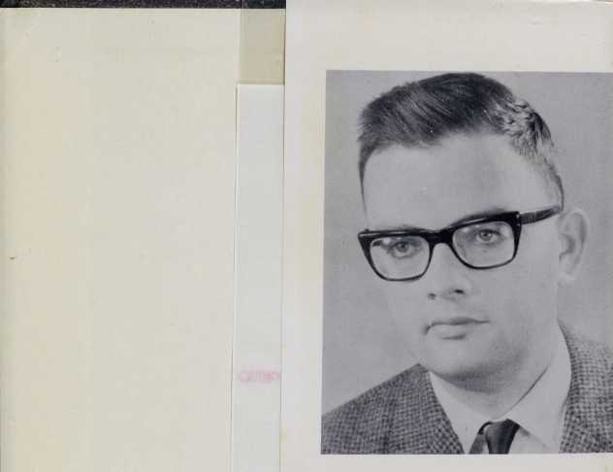

David Jaffin, born in America in 1937, earned his doctorate at New York University, where he won several awards for his scholarship. He settled in Munich, Germany, because he felt himself deeply drawn to the Central European artistic tradition.

ABELARD-SCHUMAN

LONDON NEW YORK TORONTO

Standard Book Number: 200.71548.8

